Hello! folks its awesome to have you here working towards understanding how to create a **LAMBDA** function. So, let’s get started right away with this tutorial.

Contents:

1. Selecting The Processs To Create Function
2. Configuring Basic Information
3. Configuring Advanced Settings
4. Testing

Go to AWS and search for Lambda function. Then follow it up by choosing

## **CREATE A FUNCTION**

Ideally if you are new, you select the default settings such as below picture but for more info click [ [here](https://n2ws.com/support/video-tutorials/aws-lambda-blueprint) ].

## **BASIC INFORMATION**

Then you are obligated to give a **function name**.

Depending on the **runtime** that you want to code on select the options available, for more information click [ [here](https://docs.aws.amazon.com/lambda/latest/dg/lambda-runtimes.html) ]

Next you have to configure the **architecture** by default it is **x86_64** to know more about it click [ [here](https://docs.aws.amazon.com/lambda/latest/dg/foundation-arch.html?icmpid=docs_lambda_help) ].

Follow it up by configuring the **Permissions**

To move forward you need to create an **execution role**, which is by default created by the Lambda. In this role, you can attach a policy that defines the permissions that your function needs to access other AWS services and resources. For more information click [ [here](https://docs.aws.amazon.com/lambda/latest/dg/lambda-intro-execution-role.html) ]

**PLEASE ZOOM IN**

## **ADVANCED SETTINGS**

By default, these are unchecked, but you can explore more

1. [Code Signing](https://www.venafi.com/education-center/code-signing/what-is-code-signing#:~:text=Code%20signing%20is%20simply%20a,was%20signed%20by%20the%20publisher.): simply a guarantee that the code of a program or software download has not been corrupted and tampered with after it was signed by the publisher.
2. [Function URL](https://docs.aws.amazon.com/lambda/latest/dg/lambda-urls.html): Use function URLs to assign HTTP(S) endpoints to your Lambda function.
3. [Tags](https://docs.aws.amazon.com/lambda/latest/dg/configuration-tags.html?icmpid=docs_lambda_help): Each tag is a simple label consisting of a customer-defined key and a value that makes it easier to manage, search for, and filter AWS resources.
4. [VPC](https://www.youtube.com/watch?v=O3fgul-fJCk): virtual network dedicated to your AWS account.

And once the configuring is done **create function**. You’d have a similar screen

Now as you go below you have numerous options on how to operate on your Lambda function.

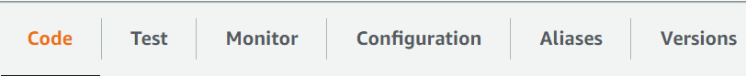

For this tutorial I have included a simple code which has best seller books data. You can also test the function to know more about testing click [ [here](https://docs.aws.amazon.com/lambda/latest/dg/testing-functions.html) ]

In Simple way to

## **TEST THE FUNCTION**

Select the Test in your code First you need to **create an event** and provide a name for it and click submit

And then paste your code if you have a custom code or else by default, you’ll have a code. Deploy it and the test.

A new tab appears **Execution Results**

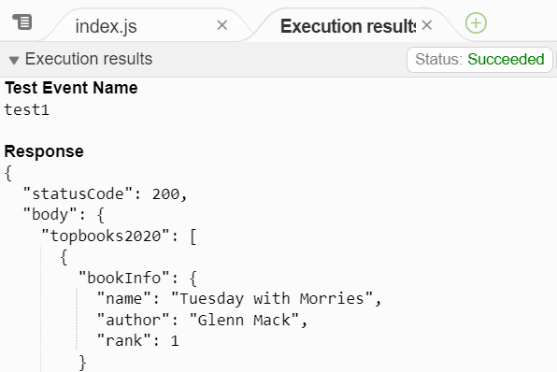

You can also import the lambda code from the Upload option .

